Title : Perform the Extraction Transformation and Loading (ETL) process to construct the database in the Sql server.
Name : - Mehatab Mahibub Sanadi
Roll No. : - CO4050
Class : - BE Computer
Subject : - Business Intelligence
*********************************************************************
Step 1: Start SQL Server
sudo systemctl start mssql-server
Step 2: Connect to SQL Server
sqlcmd -S localhost -U SA -P 'your_password'
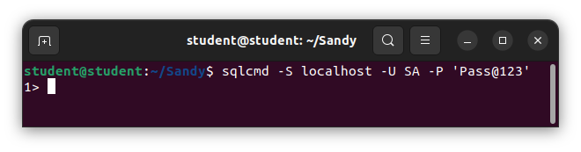
PART 1: EXTRACT (Create Source Data)
Step 3: Create Database
CREATE DATABASE ETL_DB;
GO
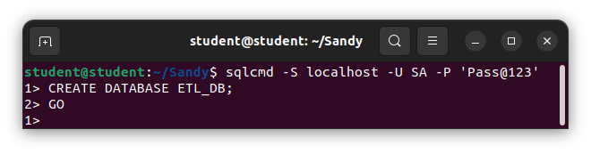
Step 4: Use Database
USE ETL_DB;
GO
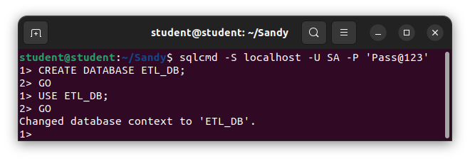
Step 5: Create Source Table
CREATE TABLE SourceData (
ID INT,
Name VARCHAR(50),
Salary INT
);
GO
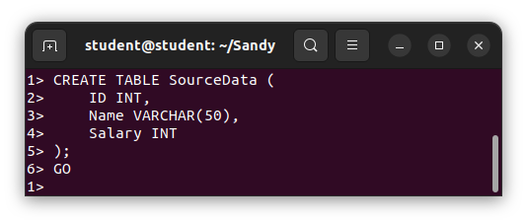
Step 6: Insert Data (Extract Phase)
INSERT INTO SourceData VALUES
(1, 'Alice', 5000),
(2, 'Bob', 6000),
(3, 'Charlie', 7000);
GO
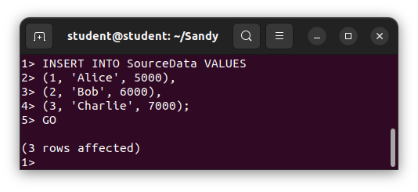
This represents data extraction from source

PART 2: TRANSFORM
Step 7: Create Destination Table
CREATE TABLE TransformedData (
ID INT,
Name VARCHAR(50),
Salary INT,
Bonus FLOAT
);
GO
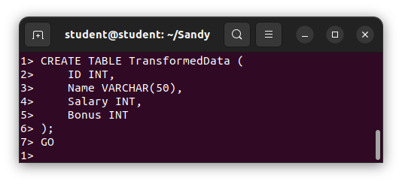
Step 8: Transform Data
Apply transformation (add 10% bonus)

INSERT INTO TransformedData
SELECT
ID,
Name,
Salary,
Salary * 0.10 AS Bonus
FROM SourceData;
GO
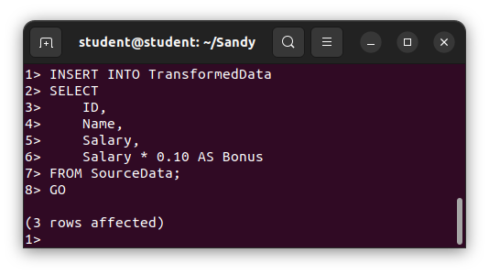
PART 3: LOAD
Step 9: Load Data into Destination
Already done in Step 8 using INSERT INTO

Step 10: Verify Output
SELECT * FROM TransformedData;
GOSELECT * FROM TransformedData;GO
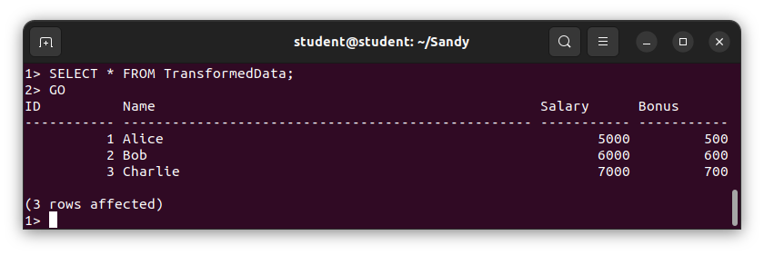
Conclusion: In this way we can perform the ETL process to construct a database in SQL Server.

